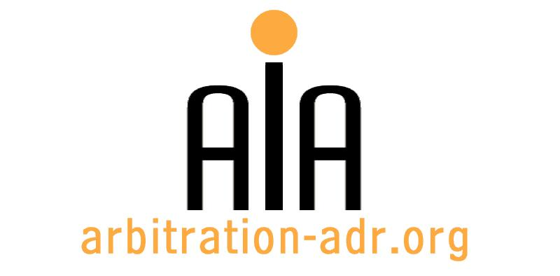

The Association for International Arbitration IVZW

Avenue Louise 146, B-1050 Brussels
tel.: +(32) 2 643 33 01
fax: +(32) 2 646 24 31
e-mail: administration@arbitration-adr.org
web: www.arbitration-adr.org

IMI

ORGANIZER: The Association for International Arbitration (AIA) IVZW.

DESCRIPTION: Qualifying Assessment Program (QAP) approved by the International Mediation Institute (IMI).

TARGET GROUPS: Mediators

ADDED VALUE: hose who take part in the AIA’s qualifying assessment program and successfully become qualified and then IMI Certified will form part of a worldwide community of experienced mediators who’s Profiles are freely searchable by users through the IMI open search engine. AIA is now open for registrations; applicants must have 200 hours mediation experience and 20 mediation cases

DATE: August 28, 2016

TIME:

LOCATION: Billiet en Co, Louizalaan 146, Brussels, Belgium

LANGUAGE: English.

FEE: 800 EUR (VAT excluded).

(PLACES ARE LIMITED AND ARE ALLOCATED ON A FIRST COME FIRST SERVED BASIS)

REGISTRATION FORM

First Name ____________________________ Last Name _________________________________
Occupation ____________________________Organization_______________________________
VAT number___________________________ Billing address______________________________
_________________________________________________________________________________
Telephone __________________________ Fax ________/_________________________________

Fee:

- 60 € (VAT excluded)

Email ____________________________________________________________________________
Signature ________________________________________________________________________

[Feel also free to suggest future events or become partner to future events]

[For other AIA events, see: www.arbitration-adr.org/activities/?p=conference&a=upcoming]

