CYPRUS: A VENUE OF CHOICE FOR INTERNATIONAL MEDIATION BETWEEN EAST AND WEST

AN INTRODUCTION TO INTERCULTURAL MEDIATION
EUROPE – ISLAMIC WORLD

A HIGH INTENSITY FIVE DAY IMMERSION WORKSHOP IN INTERNATIONAL AND INTERCULTURAL MEDIATION

Hilton Park Nicosia, Georgiou Griva Digeni, Nicosia 1507, Cyprus

Monday 13 till Friday 17 March 2017

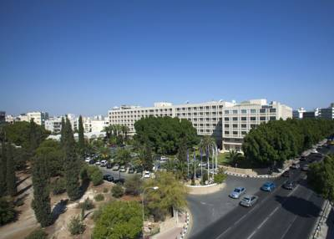

A case driven workshop for a limited group of participants guided by experienced international lawyers and mediators in exceptional surroundings.
THIS IS YOUR PROGRAM:

Monday 13 March 2017: General Principles of International Mediation

09.00 – 13h00 What is Mediation?
The effects of the perception.
What does a Mediator do precisely?
The EMTPJ Mediation Model
Other Mediation Models on the International Scene
Points of Attention in International Mediation

13h00 – 14h00 Lunch

14h00 – 18h00 Mediation Workshop: starting from a real life mediation case, participants apply the theoretical insights acquired during the morning session and exchange findings in a thorough debriefing.

Tuesday 14 March 2017: Legal Aspects of International Mediation Part 1

09h00 – 13h00 UNCITRAL Model Law on International Commercial Conciliation 2002
EU Mediation Directive 2008
USA Uniform Mediation Act 2001
European Code of Conduct for Mediators 2004
Model Standards for Mediators ABA AAA ACR
(Input from Islamic Countries)

13h00 – 14h00 Lunch

14h00 –18h00 Mediation Workshop: starting from a real life mediation case, participants apply the theoretical insights acquired during the morning session and exchange findings in a thorough debriefing.

Wednesday 15 March 2017: Cultural Aspects of International Negotiation and Mediation between EU/ USA and Islamic Countries.

09.00 – 13h00 Cultural Aspects in International Mediation Part 1

Cultural Dimensions and their Influence on Communication between the Parties:
Individualism vs Collectivism
High/ Low Power Distance
High/ Low Avoidance of Uncertainty
Masculinity vs Femininity
Long vs Short Term Orientation
Personal culture/ collective unconscious

13h00 – 14h00 Lunch

14h00 – 18h00 Mediation Workshop: starting from a real life mediation case, participants apply the theoretical insights acquired during the morning session and exchange findings in a thorough debriefing.

Thursday 16 March 2017; Cultural Aspects of International Negotiation and Mediation between EU/ USA and Islamic Countries.

09h00 – 13h00 Cultural Aspects in International Mediation Part 2

Cultural Dimensions and their Influence on Mediator Interventions:
Individualism vs Collectivism
High/ Low Power Distance
High/ Low Avoidance of Uncertainty
Masculinity vs Femininity
Long vs Short Term Orientation

13h00 – 14h00 Lunch

14h00 –18h00 Mediation Workshop: starting from a real life mediation case, participants apply the theoretical insights acquired during the morning session and exchange findings in a thorough debriefing.

Friday 17 March 2017: Legal Aspects of International Mediation Part 2

09h00 – 13h00 Legal Issues in International Intercultural Mediation

The International Mediation Clause
The International Mediation Agreement
The International Settlement Agreement
Enforceability of International Settlement Agreements
International Enforcement of Enforceability Decisions

13h00 – 14h00 Lunch

14h00 –18h00 Mediation Workshop: starting from a real life mediation case, participants apply the theoretical insights acquired during the morning session and exchange findings in a thorough debriefing.

18h00 –21h00 Closing Reception

Technical Details:

The language of the training is English.

The workshops are case driven meaning that the participants are to be active in role play as mediators as well as in negotiation teams all through the workshops. The role play is animated by the workshop guides and the experiences and rules are shared in plenary briefing and debriefing sessions.

THESE ARE YOUR GUIDES (resumé’s)

- Ebrahim SAIFUDDIN is the Founder and Chief Executive Officer of Institute for Strategic Conflict Resolution & Development. He has also served as the Chief Operating Officer of National Centre for Dispute Resolution and is the Principal trainer and Registered Mediator at the Centre. He is also on the panel of mediators of The Mediation Centre (Dubai). He has drafted the Mediation Bill 2014 for Sindh, Punjab and KPK which have been submitted to the respective provincial governments. He has also revised the previous proposed amendment of Section 89-A CPC which has been submitted in the National Assembly. For the first time in Pakistan, he devised a mediation model according to the religious and cultural norms of Pakistan to promote communal harmony and religious tolerance. He is also in the process of devising a multi-tiered de-radicalization and disengagement programme focused on tackling crime and extremism in Karachi.

- Philippe BILLIET is a senior lawyer at the Brussels law firm Billiet & Co. specializing on alternative dispute resolution, commercial law and proceedings involving sovereigns. He is frequently involved in matters with a diplomatic dimension. He also lectures on arbitration and mediation at the Brussels VUB University and at various training centers such as the European Mediation Training for Practitioners of Justice (EMTPJ) and the AIA Brussels Arbitration School (ABAS). Philippe holds a directorship mandate at the Association for International Arbitration AISBL, an international association for the promotion of ADR and ADR stakeholders. He is also member of the Advisory Board to the Brussels Diplomatic Academy (BDA), which focuses on economic diplomacy and international entrepreneurship. As an arbitrator, Philippe is registered with the following arbitration centers: the Cour Belge d’Arbitrage pour le Sport (Belgium), CEDIRES (Belgium), the Raad voor Arbitrage (Belgium), the Institute of Arbitration (Belgium), the Vienna International Arbitral Centre (Austria), the Kuala Lumpur Regional Centre for Arbitration (Malaysia), the Commission de Litiges Voyages (Belgium), the Lagos Regional Centre for International Commercial Arbitration (Nigeria), the Commercial Arbitration Centre in Harare (Zimbabwe), the Chambre Régionale d’Arbitrage Aix-en-Provence (France) and the BANI Arbitration center (Indonesia). As a mediator, Philippe is accredited in Belgium and is one of the first mediators who obtained the EMTPJ cross-border mediator certification, specializing in the settlement of international commercial disputes.

- Willem MEUWISSEN is an expert Negotiator, Mediator and Litigator in Commercial, Corporate and Real Estate Law. He is the author of several publications in commercial law and mediation. Willem teaches negotiation and mediation at the bMediation Accredited Mediators Course, at the AIA European Mediation Training for Practitioners of Justice, at the Belgian National Magistrates Training Institute (IGO). At the Brussels Diplomatic Academy of the University of Brussels he teaches International Economic Negotiation and Conflict Resolution. He is a Permanent Member of the Belgian Federal Mediation Commission and a member of the Flemish Bar Association ADR Commission. He founded Agrementor, a law firm specializing in interparty conflict resolution such as conflict negotiation and conflict mediation in international and domestic commercial conflicts. Willem has worked for many clients in Belgium, Europe and worldwide.

- Melina Karaolia is a practicing advocate in Cyprus since 2004. She has been a Partner at M. Eliades & Partners LLC since 2008. Her work encompasses a diverse range of corporate and litigation matters. She advises clients in multiple commercial, civil law issues and business law disputes. Melina has further received training and experience in the negotiation and drafting of contracts for Oil and Gas and she is a Member of the Association for International Petroleum Negotiators, a qualified Arbitrator in Cyprus and Member of the Chartered Institute of Arbitrators in London. She has also been trained and is currently actively interested in working with Mediation. She is an accredited and registered Mediator in Cyprus and has recently obtained the EMTPJ cross-border mediation certification, specializing in the settlement of international commercial disputes.

- Entafianos A. ENTAFIANOS is an attorney at law at Andreas Entafianos Law Office specializing and litigating in several fields of law, including civil, commercial, family, employment, criminal and other areas and a member of the Cyprus Bar Association since 2010. Moreover, he has obtained his EMPTJ certification in 2012.

- Mona HANNA is the President and founder of LAMAC (Lebanese Association for Mediation and Conciliation). Mona is a founder and manager of HANNA for law, Mediation and Business Consultancy, she is specialized in conflicts resolution, mediation, negotiation and arbitration. Mona is a Master Practitioner in NLP ((Neuro-linguistic programming), and consultant in relational communication. She started her career as a mediator in 2008 and as a trainer in 2010. Furthermore, she obtained her EMTPJ certification in 2013. As well she is accredited as mediator in civil & commercial matters by the Belgian Federal Mediation Commission. Mona is also a lecturer in Lebanese university – French section – master degree and trainer at ENA (Ecole Nationale d’Administation). She is the author of several publications in mediation and she initiated the first certified mediator certificates in Arabic, a certified mediation training for lawyers as well and a mediation training for internal security forces (ISF) and General Security (SG)

Practical DETAILS:

- Coffee, soft drinks and lunch included
- Course material and handouts included
- Price 1.100 EURO (vat excluded)

Additional information:
- http://www.arbitration-adr.org;
- Contact: administration@arbitration-adr.org

ORGANIZERS:

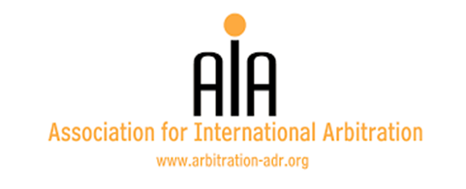
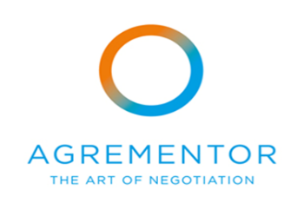

PARTNERS:

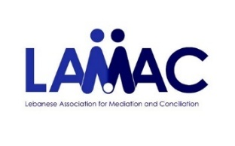
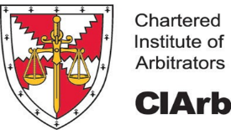
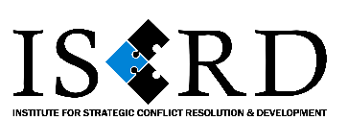

Cyprus branch

