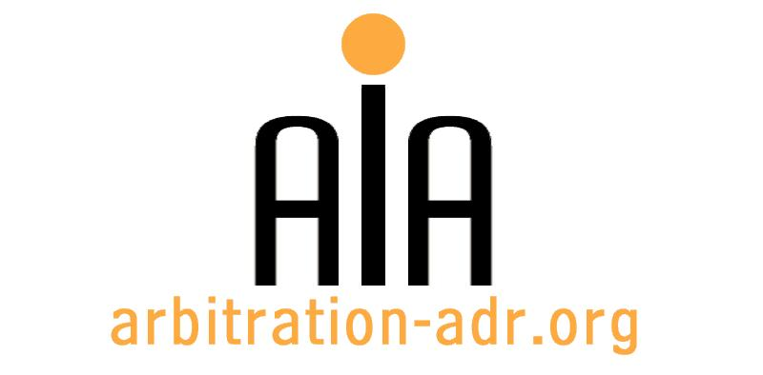

The Association for International Arbitration IVZW

Avenue Louise 146, B-1050 Brussels
tel.: +(32) 2 643 33 01
fax: +(32) 2 646 24 31
e-mail: administration@arbitration-adr.org
web: www.arbitration-adr.org

International Negotiation Training - 9th of March - 11th of March

ORGANIZER: The Association for International Arbitration (AIA) IVZW.

DESCRIPTION: The 3-day training is carefully designed to provide the respective participants a set of effective skills to practice negotiation

TARGET GROUPS: Lawyers, in-house counsel, students.

ADDED VALUE: The participant will gain negotiation skills, and will learn how to use these skills in an international commercial environment. The training is delivered over an intensive course lasting 3 days which consists of a series of lectures, discussions and negotiation case studies.

DATE: from the 9th of March until the 11th of March

TIME: 14.00-17.00.

LOCATION: Billet en CO, Louizalaan 146, Brussels

LANGUAGE: English.

FEE: 400 EUR (VAT excluded).

(PLACES ARE LIMITED AND ARE ALLOCATED ON A FIRST COME FIRST SERVED BASIS)

REGISTRATION FORM

First Name ____________________________ Last Name _________________________________
Occupation ____________________________Organization_______________________________
VAT number___________________________ Billing address______________________________
_________________________________________________________________________________
Telephone __________________________ Fax ________/_________________________________

Fee:

- 400 € (VAT excluded)

Email ____________________________________________________________________________
Signature ________________________________________________________________________

[Feel also free to suggest future events or become partner to future events]

[For other AIA events, see: www.arbitration-adr.org/activities/?p=conference&a=upcoming]

