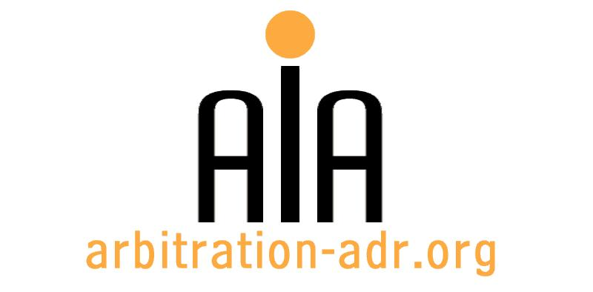

The Association for International Arbitration IVZW

Avenue Louise 146, B-1050 Brussels
tel.: +(32) 2 643 33 01
fax: +(32) 2 646 24 31
e-mail: administration@arbitration-adr.org
web: www.arbitration-adr.org

5 DAY INTENSIVE TRAINING PROGRAM ON COMMERCIAL ARBITRATION

ORGANIZER: The Association for International Arbitration (AIA) IVZW

PROJECT NAME: AIA Brussels Arbitration School

PURPOSES:
- Complete crash course on arbitration
- ABAS arbitrator certification for successful participants
- Bringing participants in contact with arbitration providers (networking)
- Continuous learning for all ADR practitioners
TARGET GROUPS: Lawyers, in-house counsels, experts & other ADR practitioners

LOCATION: Avenue Louise, 146, 1050, Brussels, Belgium

DATE: 17 - 21 Oct. 2016

LANGUAGE: English

(PLACES ARE LIMITED AND ARE ALLOCATED ON A FIRST COME FIRST SERVED BASIS)

PARTNERS

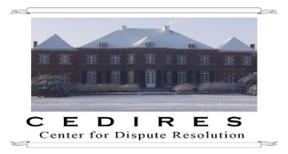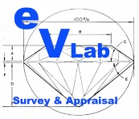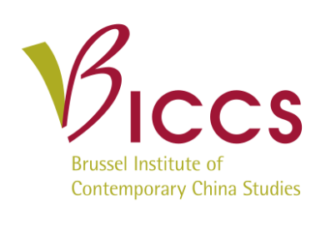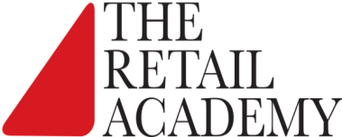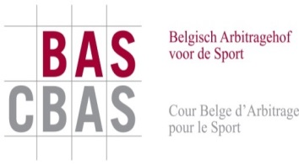

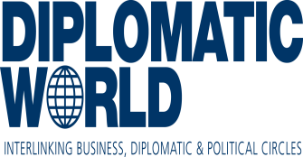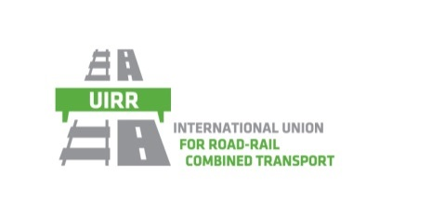
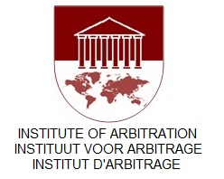
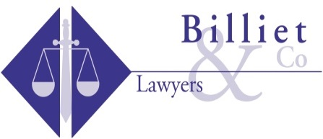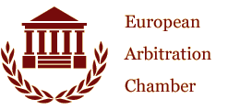
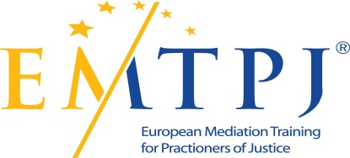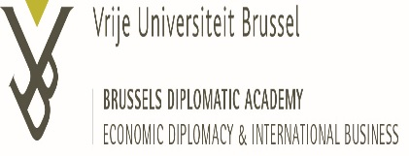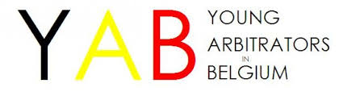

REGISTRATION FORM

First Name ____________________________ Last Name _________________________________
Occupation ____________________________Organization_______________________________
VAT number___________________________ Billing address______________________________
_________________________________________________________________________________
Telephone __________________________ Fax ________/_________________________________

Fee:
- Registration fee: 800 Euros (VAT excluded);
- ☐ Tick this box if you are an AIA member and benefit from a 50% discount
Are you already active as arbitrator? ☐ Yes ☐ No
Email ____________________________________________________________________________
Signature ________________________________________________________________________

(Send this form to administration@arbitration-adr.org)

[Feel also free to suggest future events or become partner to future events]

[For other AIA events, see: www.arbitration-adr.org/activities/?p=conference&a=upcoming]

