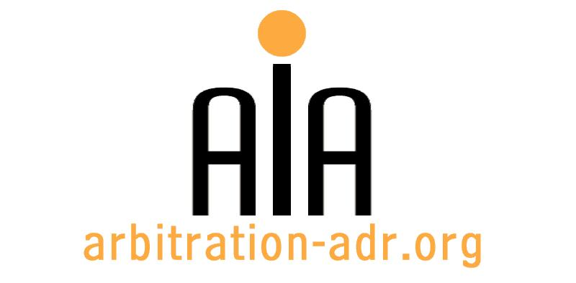

The Association for International Arbitration IVZW

Avenue Louise 146, B-1050 Brussels
tel.: +(32) 2 643 33 01
fax: +(32) 2 646 24 31
e-mail: administration@arbitration-adr.org
web: www.arbitration-adr.org

Arbitration and European Law

ORGANIZER: The Association for International Arbitration (AIA) IVZW.

DESCRIPTION: The interaction and relationship of EU law and international commercial arbitration

TARGET GROUPS: Lawyers, in-house counsel, students.

ADDED VALUE: In this course, we will consider the key changes in the Brussels Regulation (recast) for commercial parties, the consequences and interpretation of the arbitration exceptions and the relationship between EU state aid and investment protection under bilateral investment treaties. We will also discuss the procedure, minimum standards, application of Article 6 of the European Convention on Human Rights and compare BITs and EU law in investment arbitration.

DATE: April 7, 2016

TIME: 14.00-18.30.

LOCATION: Vrije Universiteit Brussel (VUB University), Boulevard de la Plaine 5, 1050 Ixelles, Brussels, Belgium.

LANGUAGE: English.

FEE: 100 EUR (VAT excluded).

(PLACES ARE LIMITED AND ARE ALLOCATED ON A FIRST COME FIRST SERVED BASIS)

REGISTRATION FORM

First Name ____________________________ Last Name _________________________________
Occupation ____________________________Organization_______________________________
VAT number___________________________ Billing address______________________________
_________________________________________________________________________________
Telephone __________________________ Fax ________/_________________________________

Fee:

- 60 € (VAT excluded)

Email ____________________________________________________________________________
Signature ________________________________________________________________________

[Feel also free to suggest future events or become partner to future events]

[For other AIA events, see: www.arbitration-adr.org/activities/?p=conference&a=upcoming]

