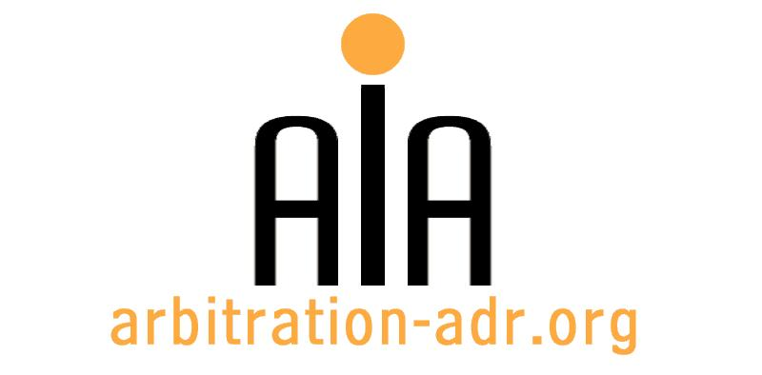

The Association for International Arbitration IVZW

Avenue Louise 146, B-1050 Brussels
tel.: +(32) 2 643 33 01
fax: +(32) 2 646 24 31
e-mail: administration@arbitration-adr.org
web: www.arbitration-adr.org

MASTER CLASS ON INVESTMENT ARBITRATION

ORGANIZERS: The Association for International Arbitration (AIA) IVZW, together with the Brussels Diplomatic Academy (VUB University)

PROJECT NAME: Master Class on Investment Arbitraton

DESCRIPTION: The law on foreign investment protection is one of the fastest developing and intellectually challenging branches of international law with high practical relevance. Investment arbitration is predicted to be a major factor in the development of the global economic system.

LOCATION: Vrije Universiteit Brussel, Pleinlaan 5, 1050 Brussels, Belgium

DATE: 19 – 22 September 2016

LANGUAGE: English

MORE INFORMATION: http://www.vub.ac.be/sites/vub/files/en/BDA/Brochure-BDA-A4-v5.pdf

(PLACES ARE LIMITED AND ARE ALLOCATED ON A FIRST COME FIRST SERVED BASIS)

REGISTRATION FORM

First Name ____________________________ Last Name _________________________________
Occupation ____________________________Organization_______________________________
VAT number___________________________ Billing address______________________________
_________________________________________________________________________________
Telephone __________________________ Fax ________/_________________________________

Fee:
- Registration fee: 1850 Euros (VAT excluded);
(50% reduction for AIA members)
Are you already active as arbitrator? ☐ Yes ☐ No
Email ____________________________________________________________________________
Signature ________________________________________________________________________

☐ Tick this box if you are an AIA member and benefit from a 50% discount

(Send this form to philippe.billiet@billiet-co.be)

[Feel also free to suggest future events or become partner to future events]

[For other AIA events, see: www.arbitration-adr.org/activities/?p=conference&a=upcoming]

[This event is supported by Billiet & Co Lawyers, Arbitrators & Mediators]

