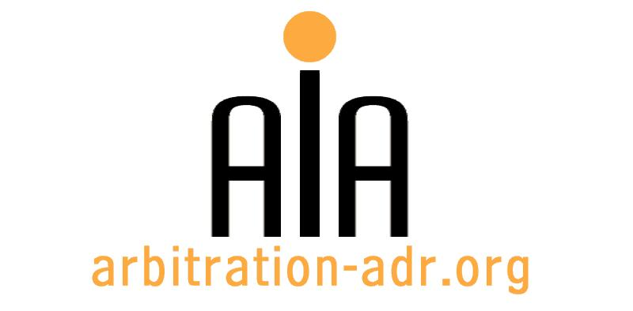

The Association for International Arbitration IVZW

Avenue Louise 146, B-1050 Brussels
tel.: +(32) 2 643 33 01
fax: +(32) 2 646 24 31
e-mail: administration@arbitration-adr.org
web: www.arbitration-adr.org

Introduction to mediation

ORGANIZER: The Association for International Arbitration (AIA) IVZW.

DESCRIPTION: Three day training program

TARGET GROUPS: Lawyers, in-house counsel, students.

ADDED VALUE: This three day training program is designed to provide an introduction to the theory and practice of mediation and focuses on the development of relevant introductory skills. It is suitable for those at all levels who seek to enhance their knowledge and skills in relation to conflict resolution within their organisations.

DATE: December 7, 2016

TIME:

LOCATION: IEU (VUB)

LANGUAGE: English.

FEE: 400 EUR (VAT excl.)

(PLACES ARE LIMITED AND ARE ALLOCATED ON A FIRST COME FIRST SERVED BASIS)

REGISTRATION FORM

First Name ____________________________ Last Name _________________________________
Occupation ____________________________Organization_______________________________
VAT number___________________________ Billing address______________________________
_________________________________________________________________________________
Telephone __________________________ Fax ________/_________________________________

Fee:

- 400 € (VAT excluded)

Email ____________________________________________________________________________
Signature ________________________________________________________________________

[Feel also free to suggest future events or become partner to future events]

[For other AIA events, see: www.arbitration-adr.org/activities/?p=conference&a=upcoming]

