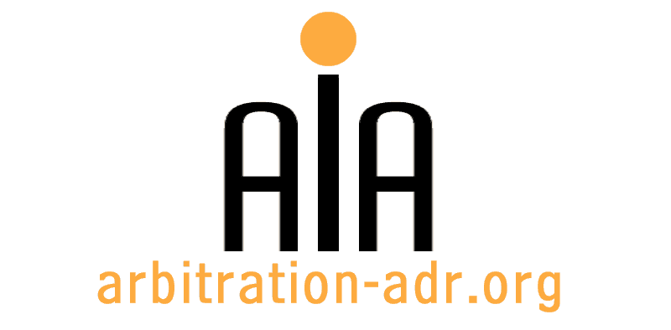

Association for International Arbitration
Avenue Louise 146/9, 1050 Brussels, Belgium

+32 2 643 3301 http://www.arbitration-adr.org
+32 2 646 2431
CONFERENCE REGISTRATION FORM
Current issues in arbitration in CIS countries

When? This event will take place on June 21, 2012 from 9.00 am until 7.00 pm
Registration will start at 8.30 am

Where? Vrije Universiteit Brussel, Karel Van Miert Building, Pleinlaan 5, 1050 B, Brussels, Belgium

Last Name |  |  |  |  |  |  |  |  | First name
Profession |  |  |  |  |  |  |  |  | Organisation
Address |  |  |  |  |  |  |  |  |  |  | Phone
 |  |  |  |  | Zip Code
City |  |  | State |  |  |  |  |  |  |  | Fax
Country |  |  |  |  |  |  |  |  |  |  | Email
Do you need a certificate of participation? |  |  |  |  | Yes | No |  |  |  |  | Date
Invoice receivers address
(If different from the address above)
ING Bank Belgium
Marnixlaan 24
1000 Brussels
Belgium
AIA Johan Billiet
IBAN paper form: BE18 3101 6881 6765 IBAN electronic form: BE18310168816765
BIC/SWIFT code: BBRUBEBB
Address
 |  |  |  |  | Zip Code
City |  |  | State
Country
VAT

Payment details: €393.25= €325 + €68.25 (21% VAT) for non-members
€332.75= €275 + €57.75 (21% VAT) for AIA members and students

Please save this form and e-mail it to us at administration@arbitration-adr.org

For Further information please check: www.arbitration-adr.org or www.aiaconferences.com

