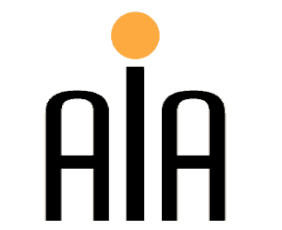 | The Association for International Arbitration IVZW  Avenue Louise 146, B-1050 Brussels  tel.: +(32) 2 643 33 01  fax: +(32) 2 646 24 31  e-mail: administration@arbitration-adr.org  web: www.arbitration-adr.org

Conference on Online Dispute Resolution
Followed by a Networking Cocktail

Wednesday 18th of September 2013 (2.00 pm – 5.00 pm)
At the Institute for European Studies, ‘Rome’ room, Pleinlaan 5
1050, Brussels, Belgium

- PURPOSE: To raise awareness and highlight the growing importance of ODR, discuss the impact of the Directive of the European Parliament and of the Council on alternative dispute resolution for consumer disputes and amending Regulation (March 12, 2013), examine the UNCITRAL online dispute resolution rules for consumers and consider what the future holds for ODR on both European and International scales.

- PRESENTATIONS: Selected speakers from will elaborate on the impact of the EU Directive and Regulation on consumers as well as the development of UNCITRAL online dispute resolution rules so as to determine what the future holds for ODR both in the EU and Internationally.

- FEE: 50 Euros (VAT included), not applicable for AIA members and EMTPJ alumni

- WORKING LANGUAGE: English

REGISTRATION FORM:

First Name ____________________________ Last Name _________________________________
Occupation _________________________________ Organization__________________________ Address__________________________________________________________________________ Telephone __________________________ Fax ________/_________________________________
Email ____________________________________________________________________________

Bank-account number: 310-1688167-65
ING Bank Belgium
Marnixlaan 24
1000 Brussels
Belgium
IBAN paper form: BE18 3101 6881 6765
IBAN electronic form: BE18310168816765
BIC/SWIFT code: BBRUBEBB

Sponsored by:

