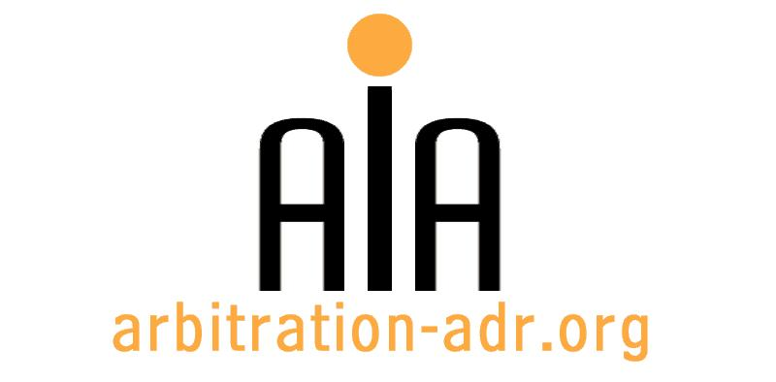

The Association for International Arbitration

Avenue Louise 146, B-1050 Brussels
tel.: +(32) 2 643 33 01
fax: +(32) 2 646 24 31
e-mail: administration@arbitration-adr.org
web: www.arbitration-adr.org

AN INTRODUCTION TO INTERCULTURAL MEDIATION
EUROPE – ISLAMIC WORLD

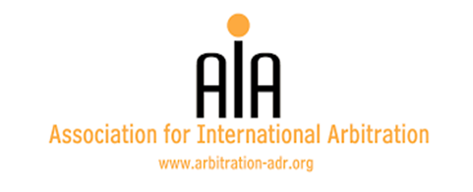
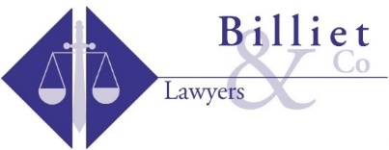
ORGANIZERS: The Association for International Arbitration (AIA); Billiet & Co Lawyers; Agrementor
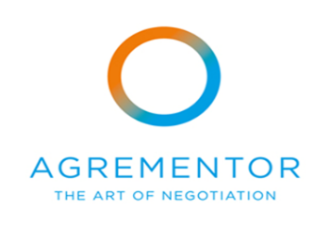

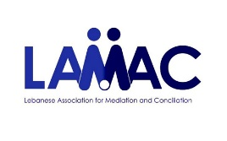
PARTNERS: Chartered Institute of Arbitration (CIARB) – Cyprus branch; Lebanese Association for Mediation and Conciliation (LAMAC); Institute for Strategic Conflict Resolution & Development (ISCRD)
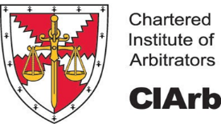
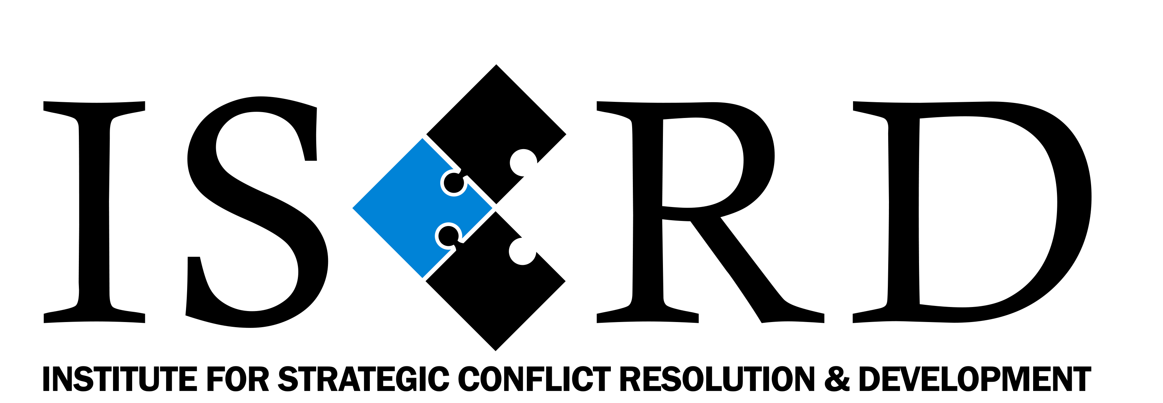
Cyprus branch

PROJECT NAME: An Introduction to Intercultural Mediation Europe – Islamic World

DESCRIPTION: A high intensity five day immersion workshop in international and intercultural mediation. The workshops are case driven meaning that the participants are to be active in role play as mediators as well as in negotiation teams all through the workshops. The role play is animated by the workshop guides and the experiences and rules are shared in plenary briefing and debriefing sessions.

LOCATION: Hilton Park Nicosia, Georgiou Griva Digeni, Nicosia 1507, Cyprus

DATE: 13 – 17 March 2017

LANGUAGE: English

REGISTRATION FORM

First Name ____________________________ Last Name _________________________________
Occupation ____________________________Organization_______________________________
VAT number___________________________ Billing address______________________________
_________________________________________________________________________________
Telephone __________________________ Fax ________/_________________________________

Fee:
- Registration fee: 1,100 Euros (VAT excluded);
- Course Material and Handouts included;
- Coffee/Tea, Soft Drinks and Lunch included;

Email ____________________________________________________________________________
Signature ________________________________________________________________________

☐ Tick this box if you are an AIA member and benefit from a 50% discount

(Send this form to administration@arbitration-adr.org)

[Feel also free to suggest future events or become partner to future events]

[For other AIA events, see: www.arbitration-adr.org/activities/?p=conference&a=upcoming]

We have made special accommodation arrangements with Hilton Park for workshop participants!
Should you wish to book with Hilton Park, please contact Elena Demosthenous directly, at:
elena.dimosthenous@hilton.com
Please entitle email – INTERCULTURAL MEDIATION WORKSHOP
t. +357 22 695210
f. +357 22 351918

