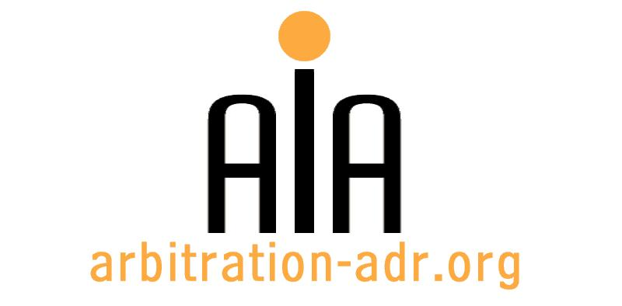

The Association for International Arbitration IVZW

Avenue Louise 146, B-1050 Brussels
tel.: +(32) 2 643 33 01
fax: +(32) 2 646 24 31
e-mail: administration@arbitration-adr.org
web: www.arbitration-adr.org

SEMINAR ON ALTERNATIVE DISPUTE RESOLUTION METHODS

ORGANIZER: The Association for International Arbitration (AIA) IVZW.

DESCRIPTION: An overview of Alternative Dispute Resolution Methods and their advantages

TARGET GROUPS: Lawyers, in-house counsel, students.

ADDED VALUE: This seminar is designed to provide its participants with an overview of the various existing dispute resolution methods (e.g. med-arb, arb-med, arb-med-arb, conciliation, mediation, arbitration, baseball arbitration, etc). It is specifically aimed to provide knowledge to those who are interested in dispute resolution.

DATE: 28 January 2016.

TIME: 14.00-17.00.

LOCATION: Vrije Universiteit Brussel (VUB University), Boulevard de la Plaine 5, 1050 Ixelles, Brussels, Belgium.

LANGUAGE: English.

FEE: 60 EUR (VAT excluded).

(PLACES ARE LIMITED AND ARE ALLOCATED ON A FIRST COME FIRST SERVED BASIS)

REGISTRATION FORM

First Name ____________________________ Last Name _________________________________
Occupation ____________________________Organization_______________________________
VAT number___________________________ Billing address______________________________
_________________________________________________________________________________
Telephone __________________________ Fax ________/_________________________________

Fee:

- 60 € (VAT excluded)

Email ____________________________________________________________________________
Signature ________________________________________________________________________

[Feel also free to suggest future events or become partner to future events]

[For other AIA events, see: www.arbitration-adr.org/activities/?p=conference&a=upcoming]

