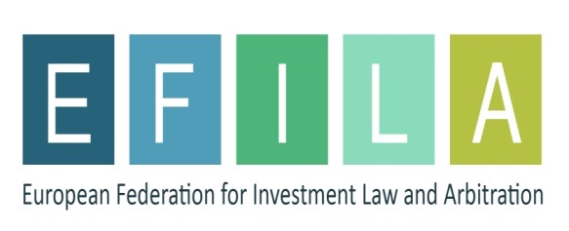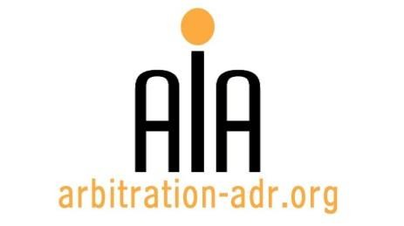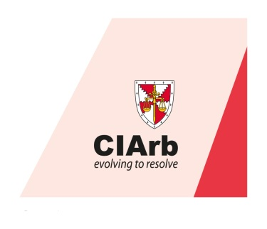

SEMINAR: UPDATES ON EU RELATED ARBITRATION
(A selection of new, controversial and hot topics)

ORGANIZERS:
- The Association for International Arbitration (AIA);
- The European Federation for investment Law and Arbitration (EFILA); and
- The Chartered Institute of Arbitrators (Ciarb)
PROJECT NAME: Updates on EU related Arbitration
DESCRIPTION: This seminar aims to give a broad update on new/ controversial/ hot topics in relation to arbitration and EU related law & practices. Over the years a lot has evolved and the seminar will address evolutions in fields such as the Brussels I Bis Regulation, human rights, state aid, the arbitrability of EU competition claims, investment protection under BITs/MITs, etc.

TARGET GROUPS: Attorneys specializing in dispute resolution, in-house counsel, MEP`s, a.o.

DATE: 27 May 2016

TIME: 14.00-18.30h

LOCATION: VUB University, Pleinlaan 9, 1050 Brussels. (Room WEBER – 1st Floor)

LANGUAGE: English.

FEE: 200 EUR (VAT excluded)
(AIA members, EFILA members and CIarb members receive a 50 % discount)

(PLACES ARE LIMITED AND ARE ALLOCATED ON A FIRST COME FIRST SERVED BASIS)

PROVISIONAL PROGRAM
Time allocation
Host speaker: Philippe Billiet, Billiet & Co Lawyers, Arbitrators & Mediators
OPENING  SPEECH |  | Topic: The reputation of arbitration  Keynote speaker: Laurence Burger, FCIArb, Chair of the European Branch |  |  | 14.00 – 14.10
First Panel
(Moderator: Iuliana Iancu, Hanotiau & van den Berg)
2. | EU state vs. investment arbitration under BITS |  |  | Konstaninos Adamantopoulos  K.A. Legal – Billiet & Co | 14.10 – 14.25
3. | Potential Investment Arbitration Consequences of the Brexit |  |  | Christophe Guibert De Brouet  Lalive | 14.25 – 14.40
4. | CDC judgment of the Court of Justice |  |  | Assimakis Komninos  White & Case | 14.40 – 14.55
5. | The arbitrability of competition law issues |  |  | Jean-Francois Bellis  Van Bael & Bellis | 14.55 – 15.10
6. | Q&A |  |  |  | 15.10 – 15.25
Coffee break: 15.25 – 16.00

Second panel
(Moderator: Pietro Ortolani, Max Planck Institute for International, European and Regulatory Procedural Law)
7. |  |  | The Public Policy Exception in the New York Convention) and the risk of non- enforceability of arbitral awards for violation of EU competition law provisions | Damien Geradin  Edge legal | 16.00 – 16.15
8. |  |  | TTIP: a story of changes, challenges and concessions - the way to a Standing Court of Arbitration | Zena Prodromou  White & Case | 16.15 – 16.30
9. |  |  | TBD | Rupert Schlegelmilch European Commission | 16.30 – 16.45
10. |  |  | TBD | Pieter Kuypers  AKD | 16.45 – 17.00
11. |  |  | Q & A and debate |  | 17.00 – 17.15
CONCLUDING REMARKS |  |  | Keynote speaker: Dr. Nikos Lavranos, Secretary General, EFILA |  | 17.15 – 17.25
Networking reception: 17.25 – 18.30

REGISTRATION FORM

First Name Last Name

Occupation Organization

VAT number Billing address

Telephone Fax /
Fee:

o Tick this box if you are a professional: 200 € (excl. VAT)

o Tick this box if you are a member of AIA, CIarb or EFILA (reduced fee: 100 Euro excl. VAT)

Email ________________________________________________________

Signature

(Send this form to Philippe.billiet@billiet-co.be)

[Feel free to suggest future events or become partner to future events]

[For other AIA events, see: www.arbitration-adr.org/activities/?p=conference&a=upcoming]

[This event is supported by Billiet & Co Lawyers, Arbitrators & Mediators]

