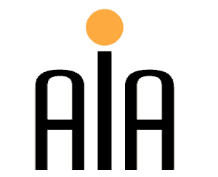 | The Association for International Arbitration IVZW  Avenue Louise 146, B-1050 Brussels  tel.: +(32) 2 643 33 01  fax: +(32) 2 646 24 31  e-mail: administration@arbitration-adr.org  web: www.arbitration-adr.org
Seminar on Collective Redress through ADR
Followed by a Networking Cocktail

Wednesday 12th of March 2014 (2.00 pm – 5.00 pm)
At the Institute for European Studies, ‘Rome’ room, Pleinlaan 5
1050, Brussels, Belgium

SUBJECT: The topics include: (1) Recent developments of Belgian Law on collective redress; (2) Collective Redress in the EU including the European Commission’s Communication "Towards a European Horizontal Framework for Collective Redress” and the Recommendation on “common principles for injunctive and compensatory collective redress mechanisms in the Member States concerning violations of rights granted under Union Law”; (3) The impact of Collective Redress mechanisms on Consumer Protection; (4) Class Arbitration and (5) the role of Mediation in Collective Redress.
BAR POINTS: 3 points will be allocated

LANGUAGE: English

SEMINAR FEE: 75.00 Euros (incl VAT)

REGISTRATION FORM:

First Name ____________________________ Last Name _________________________________
Occupation _________________________________ Organization__________________________ Address__________________________________________________________________________ Telephone __________________________ Fax ________/_________________________________
Email ____________________________________________________________________________
Signature ________________________________________________________________________

☐ Tick this box if you would like to use this opportunity to order the book P. Billiet (2013) ‘Class Arbitration in the European Union’, ISBN 9789046604908, Maklu-Uitgevers, 242p and benefit from a discount price (40 EUR incl VAT instead of 65 EUR incl VAT) for the purchase of this book. These books will then be distributed during the seminar.
Bank-account number: 310-1688167-65
ING Bank Belgium
Marnixlaan 24
1000 Brussels
Belgium
IBAN paper form: BE18 3101 6881 6765
IBAN electronic form: BE18310168816765
BIC/SWIFT code: BBRUBEBB

Sponsored by:

