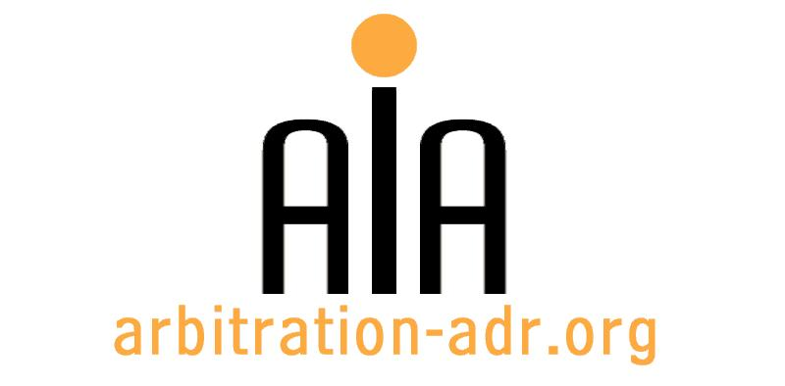

The Association for International Arbitration IVZW

Avenue Louise 146, B-1050 Brussels
tel.: +(32) 2 643 33 01
fax: +(32) 2 646 24 31
e-mail: administration@arbitration-adr.org
web: www.arbitration-adr.org

SEMINAR ON SUSTAINABLE DEVELOPMENT AND INTERNATIONAL ARBITRATION

ORGANIZERS: The Association for International Arbitration (AIA) IVZW, together with AIA Italy and ICC Italy.

PROJECT NAME: Sustainable Development and International Arbitration

DESCRIPTION: This seminar looks at what sustainable development is really about, the trends and effects of sustainable development law in the commercial arbitration world, and enhancing environmental protection through ISDS.

LOCATION: Vrije Universiteit Brussel (VUB University), Pleinlaan 5, B-1050, Brussels, Belgium.

DATE: 10 November 2016 (2pm – 6.30pm)

LANGUAGE: English

PROGRAM: TBD

REGISTRATION FORM

First Name ____________________________ Last Name _________________________________
Occupation ____________________________Organization_______________________________
VAT number___________________________ Billing address______________________________
_________________________________________________________________________________
Telephone __________________________ Fax ________/_________________________________

Fee:
- Registration fee: 200 Euros (VAT excluded);
(+ 50% reduction for AIA members)
Are you already active as arbitrator? ☐ Yes ☐ No
Email ____________________________________________________________________________
Signature ________________________________________________________________________

☐ Tick this box if you are an AIA member and benefit from a 50% discount

(Send this form to Alexander.Billiet@billiet-co.be)

[Feel also free to suggest future events or become partner to future events]

[For other AIA events, see: www.arbitration-adr.org/activities/?p=conference&a=upcoming]

[This event is supported by Billiet & Co Lawyers, Arbitrators & Mediators]

