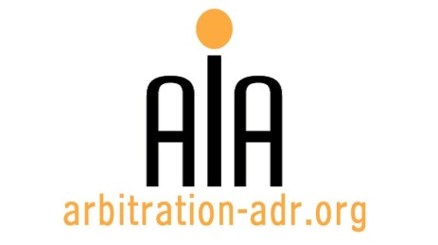

Third Party Funding

ORGANIZERS:
- Association for International Arbitration (AIA); and
- The Danish Institute of Arbitration (DIA)

PROJECT NAME: Vrije Universiteit Brussels

TARGET GROUPS: Attorneys specializing in dispute resolution, in-house counsel, ..

DATE: 9 June 2016

TIME: 14.00-18.30h

LOCATION: VUB University, Pleinlaan 9, 1050 Brussels. (Room WEBER – 1st Floor)

LANGUAGE: English.

FEE: 200 EUR (VAT excluded)
(AIA members and members of the Danish Arbitration Association receive a 50 % discount)

(PLACES ARE LIMITED AND ARE ALLOCATED ON A FIRST COME FIRST SERVED BASIS)

PROVISIONAL PROGRAM
Host speaker: Philippe Billiet, Billiet & Co Lawyers, Arbitrators & Mediators

OPENING | Duarte Henriques  ”The definition of TPF” |  |  | 14.00 – 14.10
First Panel: THE PRACTITIONER’s PERSPECTIVE
(Moderator: Dan Terkildsen, Danders & More)
TPF and the impartiality and independence of the arbitrators |  |  | Niccolò Landi  Gianni, Origoni, Grippo, Cappelli & Partners | 14.10 – 14.30
The reaction of Respondent States to TPF |  |  | Angelynn Meya  Foley Hoag | 14.30 – 14.50
The recent approach on security for costs in TPF arbitral proceedings |  |  | Carlos González-Bueno  González-Bueno SLP | 14.50 – 15.10
Q&A and debate |  |  |  | 15.10 – 15.25
Coffee break: 15.25 – 16.00
Second Panel: THE PROVIDER’s PERSPECTIVE
(Moderator: René Offersen, LETT)
“What’s so bad about TPF?” |  |  | Leslie Perrin  Calunius Capital | 16.00 – 16.20
Update on how courts, tribunals, policymakers and legislators have treated TPF in recent times |  |  | Steven Friel  Woodsford Litigation Funding | 16.20 – 16.40
“Portfolio financing: From litigation funding to corporate financing” |  |  | Dr Ianika Tzankova  Burford Capital | 16.40 – 17.00
Q & A and debate |  |  |  | 17.00 – 17.15
Concluding remarks |  | Johan Billiet  Billiet & Co |  | 17.15 – 17.25
Networking reception: 17.25 – 18.30

REGISTRATION FORM

First Name ____________________________ Last Name _________________________________
Occupation ____________________________Organization_______________________________
VAT number___________________________ Billing address______________________________
_________________________________________________________________________________
Telephone __________________________ Fax ________/_________________________________

Fee:

- Tick this box if you are a professional: 200 € (excl. VAT) or

- Tick this box if you are a member of AIA or of the Danish Arbitration Association (fee 100 € excl. VAT)
Email ____________________________________________________________________________
Signature ________________________________________________________________________

(Send this form to Philippe.billiet@billiet-co.be)

[Feel free to suggest future events or become partner to future events]

[For other AIA events, see: www.arbitration-adr.org/activities/?p=conference&a=upcoming]

[This event is supported by Billiet & Co Lawyers, Arbitrators & Mediators]

