AN INTRODUCTION TO INTERCULTURAL MEDIATION
EUROPE – ISLAMIC WORLD
ORGANIZERS: A HIGH INTENSITY FIVE DAY IMMERSION TRAINING IN INTERNATIONAL AND
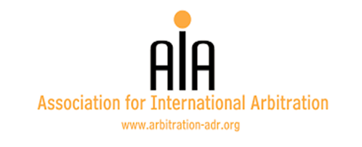
INTERCULTURAL MEDIATION
Hilton Park Nicosia, Georgiou Griva Digeni, Nicosia 1507, Cyprus
Monday 13 till Friday 17 March 2017
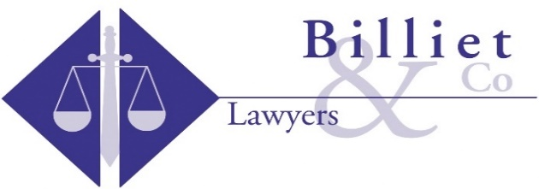
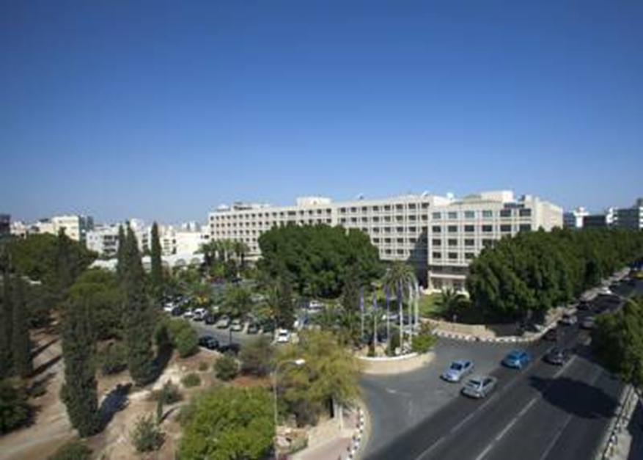

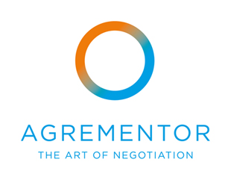

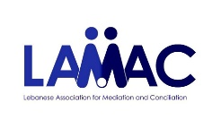
PARTNERS:
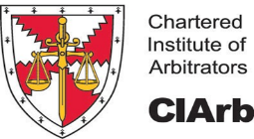
Do not miss out on this opportunity!
For registration and more information on the course please contact:
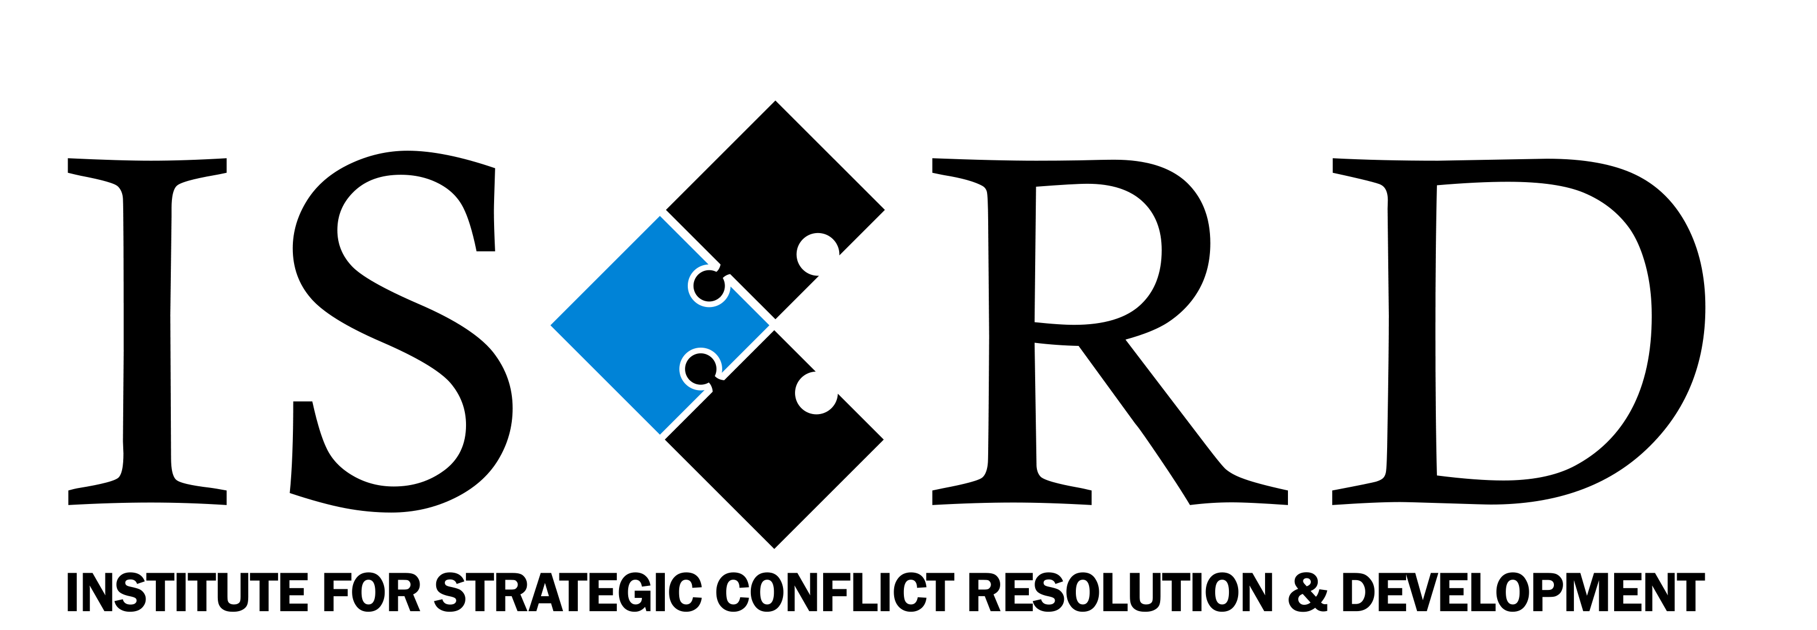 administration@arbitration-adr.org
Cyprus branch +32 2 643 33 07

